 Predictors of outcome in Internet-delivered cognitive behavior therapy for pediatric obsessive-compulsive disorder: A multi-method approach

Lenhard, Fabian, MSc, Centre for Psychiatry Research, Department of Clinical Neuroscience, Karolinska Institutet; Stockholm Healthcare Services, Stockholm County Council, Stockholm, Sweden

Sauer, Sebastian, PhD, FOM Hochschule für Oekonomie & Management, Essen, Germany

Andersson, Erik, PhD, Centre for Psychiatry Research, Department of Clinical Neuroscience, Karolinska Institutet, Stockholm, Sweden

Mataix-Cols, David, PhD, Centre for Psychiatry Research, Department of Clinical Neuroscience, Karolinska Institutet; Stockholm Healthcare Services, Stockholm County Council, Stockholm, Sweden

Rück, Christian, PhD, Centre for Psychiatry Research, Department of Clinical Neuroscience, Karolinska Institutet; Stockholm Healthcare Services, Stockholm County Council, Stockholm, Sweden

Månsson, Kristoffer, PhD, Department of Clinical Neuroscience, Karolinska Institutet, Stockholm, Sweden; Linköping University, Linköping, Sweden

Serlachius, Eva, PhD, Centre for Psychiatry Research, Department of Clinical Neuroscience, Karolinska Institutet; Stockholm Healthcare Services, Stockholm County Council, Stockholm, Sweden

Corresponding author: Fabian Lenhard, Child and Adolescent Psychiatry Research Centre, Gävlegatan 22, 113 30 Stockholm, Sweden, [fabian.lenhard@ki.se](mailto:fabian.lenhard@ki.se), tel: +46 8 514 522 12

**Author contribution:**

**Acknowledgements & funding:** This study was funded by the Stockholm County Council (PPG project 20120167, 20140085), Swedish Research Council for Health, Working Life and Welfare (2014-4052) and Jane & Dan Olsson Foundation. Dr. Rück was supported by a grant from the Swedish Research Council (K2013-61P-22168). The funders did not have any involvement in the study design, data collection, analysis and interpretation of the data, writing of the report or the decision to submit the article for publication.

**Keywords:** Obsessive-compulsive disorder; cognitive behavior therapy; Internet; prediction

# Abstract

Background  
Methods  
Results  
Conclusions

# Background

Obsessive-compulsive disorder (OCD) is characterized by recurrent, anxiety provoking thoughts and compulsive behaviors, often aimed to prevent a dreaded event or feeling of distress (American Psychiatric Association, 2013). OCD affects 1 to 2 children out of 100 (Angst et al., 2004; Valleni-Basile et al., 1994) and is commonly associated with severe impairments in academic, social and family functioning (Piacentini, Bergman, Keller, & McCracken, 2003), not to mention the associated suffering of patients and family members.

Cognitive behavior therapy (CBT) is recommended as the first-line treatment for pediatric OCD (Geller & March, 2012; NICE, 2006; Socialstyrelsen, 2009). However only a minority of OCD sufferers get access to CBT due to treatment barriers such as geographical distances, limited resources including shortage of trained therapists (Goodwin, Koenen, Hellman, Guardino, & Struening, 2002; Wahl et al., 2010). As a solution, internet-delivered CBT treatments (ICBT) have been proposed as an alternative.

In ICBT the patient works with the same content and treatment components as in traditional face-to-face CBT, the only difference being that the intervention is presented via an online platform, thus making treatment available independent of geographical distances, office hours or limited clinician resources. Clinician contact, if included in the intervention, is usually given via asynchronous online messages. ICBT has been shown to be effective for various mental health disorders in adults with over 100 randomized controlled trials (RCTs) and depression, anxiety and pain disorders being the most frequent targeted conditions (Hedman, Ljótsson, & Lindefors, 2012). However, the child ICBT field has been lagging behind significantly. A recent review found 25 ICBT studies targeting children and adolescents, of which 19 were RCTs (Vigerland et al., n.d.), showing a field still in its infancy. Regarding childhood OCD and ICBT, two open trials (Lenhard et al., 2014b; Rees, Anderson, Kane, & Finlay-Jones, 2016) and a recent RCT (Lenhard, Andersson, et al., 2016) demonstrated promising effects of ICBT for pediatric OCD, with substantial symptom reductions on primary and secondary outcomes.

ICBT is clearly not expected to substitute traditional face-to-face CBT. Rather, it may be implemented as a first-line, low cost intervention in a stepped care model, freeing resources for more complex cases that crave individualized face-to-face CBT (David Mataix-Cols & Marks, 2006). The two above mentioned pediatric OCD trials have indicated responder rates of about 30 – 70% at the 3-month follow-up (Lenhard et al., n.d., 2014), possibly somewhat lower than face-to-face CBT, were on average 68% of patients respond (McGuire et al., 2015). Consequently, all patients are not expected to benefit from ICBT, and some might need or prefer face-to-face CBT. Yet, it remains unclear for which patients ICBT works.

In other words, the identification of which subgroup of patients ICBT works for is essential in order to offer the right patients the right treatment. Currently, there are few studies that have answered that question, and to the best of our knowledge there are no studies in the child and adolescent field that have targeted the question of which patients benefit from the intervention. In absence of pediatric ICBT prediction studies, the face-to-face CBT literature could potentially indicate predictor candidates that likely will be important even in ICBT. A review from 2008 analyzed 21 pediatric OCD studies (of which six were CBT studies) (Ginsburg, Kingery, Drake, & Grados, 2008). Variables that were identified as significant predictors of poorer response to CBT were baseline OCD severity and family dysfunction.

Since the review of Ginsburg et al, we found six additional predictor studies. **Table 1** gives an overview of the results. Studies until 2005 were included in the review of Ginsburg et al.

*Table 1:* Overview of previous studies’ significant (*) and non-significant (n.s.) predictors for CBT outcome in pediatric OCD

|  |  |  |  |  |  |  |  |  |  |  |  |  |
| --- | --- | --- | --- | --- | --- | --- | --- | --- | --- | --- | --- | --- |
| *Study* | Bolton et al., 1995 | Benazon et al., 2002 | Piacentini et al., 2002 | Himle et al., 2003 | Barrett et al., 2004 | Barrett et al., 2005 | Storch et al., 2008 | Garcia et al., 2010 | Peris et al., 2012 | Mancebo et al., 2014 (longtime follow-up) | Rudy et al., 2014 | Torp et al., 2014 |
| *Study sample size* | N = 14 | N = 16 | N = 42 | N = 19 | N = 77 | N = 48 | N = 92 | N = 112 | N = 49 | N = 60 | N = 78 | N = 269 |
| *Prediction method* | Fisher's Exact  Test | T-tests | Correlations & multiple regression | T-test, repeated measures analysis | repeated measures mixed factorial ANOVA | Multiple regression | Stepwise logistic and linear regression | General linear model (GLM) | Logistic regression | Stepwise Cox proportional hazard regression | Hierarchical linear and logistic multiple regression analyses | Stepwise multivariate regression |
| *Demographic variables* |  |  |  |  |  |  |  |  |  |  |  |  |
| Sex |  | n.s. | n.s. |  |  |  |  | n.s. |  | n.s. | * | n.s. |
| Age |  |  | n.s. |  | n.s. |  |  | n.s. |  | n.s. | n.s. | * |
| Household income/SES |  |  |  |  |  |  |  | n.s. |  |  |  | n.s. |
| *OCD related variables* |  |  |  |  |  |  |  |  |  |  |  |  |
| OCD severity | n.s. |  | * |  |  | * |  | * |  | n.s. | * | n.s. |
| OCD functional impairment |  |  | * |  |  |  |  | * |  | * | n.s. | n.s. |
| Social adjustment | n.s. |  |  |  |  |  |  |  |  |  |  |  |
| Onset of OCD | n.s. |  | n.s. |  |  |  |  |  |  | n.s. |  |  |
| Duration of OCD |  |  | n.s. |  |  |  |  |  |  | * |  | n.s. |
| Insight |  |  |  |  |  |  |  | * |  |  |  |  |
| OCD dimensions |  |  |  |  |  |  | n.s. |  |  |  |  |  |
| *Comorbidity* |  |  |  |  |  |  |  |  |  |  |  |  |
| Externalizing comorbidity |  |  | n.s. |  |  |  |  | * |  |  | n.s. | n.s. |
| Comorbid anxiety |  | n.s. | n.s. |  |  | n.s. |  | n.s. |  |  | n.s. | n.s. |
| Comorbid depression |  |  | n.s. |  |  | n.s. |  | n.s. |  |  | n.s. | n.s. |
| Comorbid tics |  |  | n.s. | n.s. |  |  |  |  |  |  |  | n.s. |
| *Family variables* |  |  |  |  |  |  |  |  |  |  |  |  |
| Family accommodation |  |  |  |  |  |  |  | * |  |  | * | n.s. |
| Family dysfunction |  |  |  |  |  | * |  | n.s. | * |  |  |  |
| Family history of OCD |  |  |  |  |  |  |  | n.s. |  |  |  | n.s. |
| Parental psychopathology | n.s. |  |  |  |  |  |  | n.s. |  |  |  | n.s. |
| *Other* |  |  |  |  |  |  |  |  |  |  |  |  |
| Medication |  |  | n.s. | n.s. | n.s. |  |  |  |  |  |  |  |
| Therapist experience |  |  | n.s. |  |  |  |  |  |  |  |  |  |
| Therapy adherence |  |  | n.s. |  |  |  |  |  |  |  |  |  |

To summarize the results displayed in **Table 1**, prediction of pediatric OCD treatment outcome is noticeably inconclusive at this point and very few variables can be considered reliable predictors. Reasons for this could be numerous. Firstly, we note that different definitions of treatment outcome are used, ranging from dimensional measured symptom severity on the Children’s Yale-Brown Obsessive Compulsive Scale (CY-BOCS), Clinical Global Impression (CGI), or the National Institute of Mental Health Global Obsessive Compulsive Scale (NIMH-GOCS), to various operationalizations of dichotomized outcomes of remission from OCD and treatment response. Naturally, such differences in outcome variables would be expected to cause different results when conducting prediction analyses. Secondly, as Table 1 shows, there are methodological differences between studies regarding the choice of statistical method when conducting predictor analyses, ranging from correlations and t-tests, classical regression analyses to hierarchical regression modeling. One could hypothesize that the inconsequent use of different statistical models across studies contributes, in part, to the inconsistencies in finding reliable predictors.

Perhaps novel statistical approaches could solve the discrepancies in the field. For example, a recent study in adult OCD (Askland et al., 2015) applied a “machine learning” approach to predict remission, explaining 50% of the variance in the outcome. Amongst the 24 most important predictors were several Yale–Brown Obsessive Compulsive Scale (Y-BOCS) items, items from the NEO Five Factor Inventory (Costa and McCrae, 1992) and and subscale scores, cleaning/washing compulsion scores, and several self-report items from social adjustment scales. The chosen Random Forests classification was able to predict remission outcomes with an error rate of 24.6%.

Machine learning comprises not only classical probability based approaches, but also so-called “algorithmic” methods which do not rely on probability methods (Breiman, 2001). Machine learning algorithms build on a variety of analytic approaches, both linear and non-linear, and may thus discover hidden patterns that are not discernable by classical linear models (Monuteaux & Stamoulis, 2016).

Another advantage with the machine learning approach is that results can directly be validated by dividing the original sample into a “training” subsample, to establish the predictive algorithm, and then a “test” subsample, in which to test whether the algorithm is replicable in new subjects. Thus, the model is built on the training sample (usually 80% of the full sample), and subsequently used to predict the cases of the remaining test sample. This way of analyzing data may overcome the problem of “overfitting” (i.e. the situation where a model not only fits “real signal” but noise too; James et al., 2013).

## Study aims

The aim of this study was to use different statistical procedures to explore baseline patient characteristics as possible predictors of treatment success in ICBT for pediatric OCD.

# Methods

## Participants

Sixty-seven adolescents with OCD (12 – 17 years) participated in a randomized controlled study (Lenhard, Andersson, et al., 2016) and had received either immediate or delayed (12 weeks) ICBT. Six participants in the delayed ICBT group dropped out before treatment could start. In order to maximize power, we pooled the results from both groups rendering a total sample of 61 participants. The treatment, assessment points and procedures were identical in the two groups and they did also not differ significantly in terms of baseline characteristics or treatment outcome. See **Figure 1** for details on the participant flow throughout the trial and **Table 2** for a summary of baseline characteristics and ICBT outcome at the 3-month follow-up.

**Figure 1:** Study flow chart

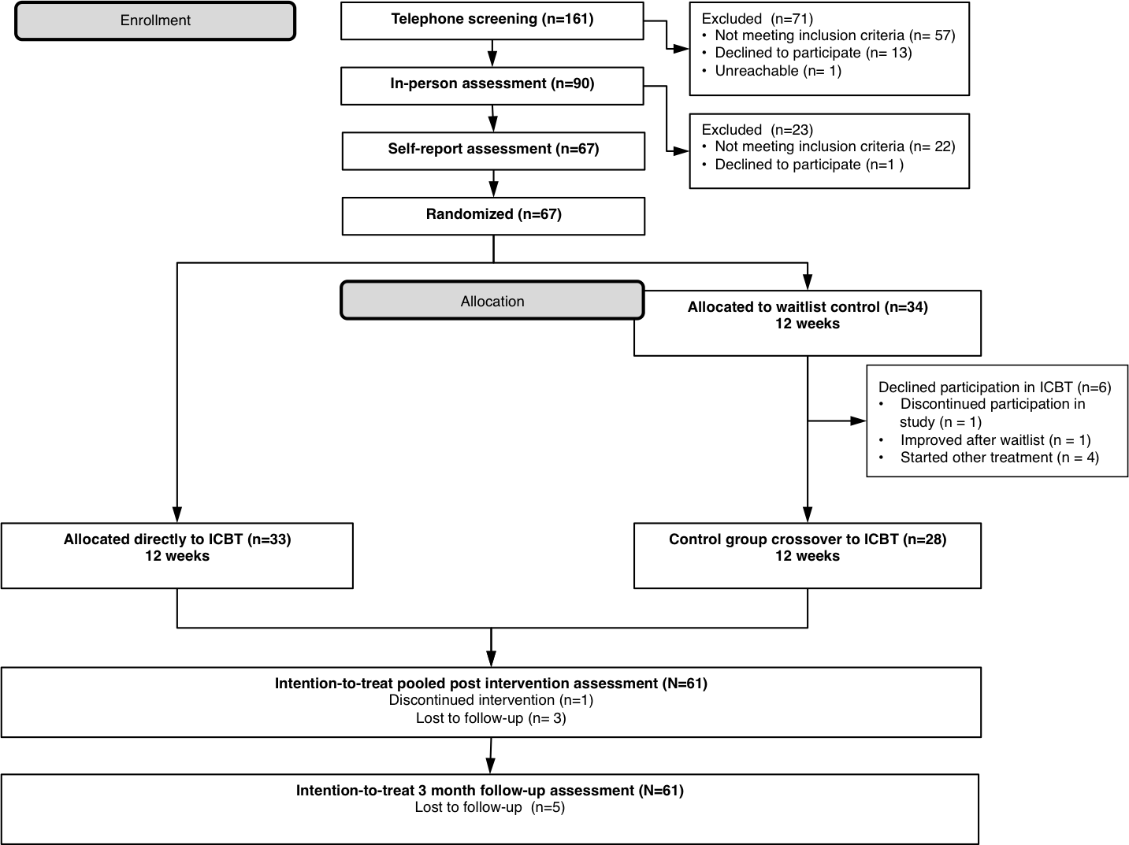

**Table 2:**Baseline characteristics and ICBT outcome at post-treatment and 3 month follow-up

|  |  |  |
| --- | --- | --- |
| **Variable** | **Mean / %** | **Std. Dev.** |
| Sex (% females) | 43% |  |
| age | 14.44 | 1.68 |
| *Country of birth* |  |  |
| Sweden | 92% |  |
| Other European | 5% |  |
| Asian | 3% |  |
| *Parental education level* |  |  |
| Other | 15% |  |
| College | 5% |  |
| High school | 23% |  |
| Primary | 2% |  |
| Doctoral degree | 2% |  |
| University | 51% |  |
| Vocational | 3% |  |
| *Referral to study* |  |  |
| Self-referral | 92% |  |
| CAMHS referral | 8% |  |
| Distance to research unit (km) | 57.57 | 103.50 |
| *Medication* |  |  |
| none | 75% |  |
| SSRI | 18% |  |
| Central stimulants | 3% |  |
| SSRI & central stimulants | 2% |  |
| Trycyclic antidepressants | 2% |  |
| Any medication (yes/no) | 25% |  |
| *Previous treatment experience* |  |  |
| None | 52% |  |
| CAMHS councelling | 39% |  |
| CAMHS CBT | 5% |  |
| CAMHS dynamic therapy | 3% |  |
| Previous CBT for OCD | 23% |  |
| *Comorbidity* |  |  |
| Depression | 8% |  |
| Dystymia | 3% |  |
| Panic Disorder | 8% |  |
| Social Phobia | 8% |  |
| Specific Phobias | 11% |  |
| PTSD | 2% |  |
| Tourette Syndrom | 7% |  |
| ADHD | 10% |  |
| GAD | 13% |  |
| *Number of comorbid diagnoses* |  |  |
| One | 57% |  |
| Two | 28% |  |
| Three | 5% |  |
| Four | 2% |  |
| *Baseline OCD symptoms* |  |  |
| CY-BOCS obsessions score | 10.95 | 2.40 |
| CY-BOCS compulsions score | 11.64 | 2.22 |
| CY-BOCS total score | 22.59 | 4.21 |
| Insight | 1.69 | 0.79 |
| Avoidance | 1.60 | 0.95 |
| OCD onset (age) | 10.52 | 2.72 |
| OCD duration (years) | 4.06 | 2.90 |
| OCD symptom dimensions |  |  |
| Checking & obsessive hoarding | 34% |  |
| Aggressive, sexual or religious obsessions | 48% |  |
| Contamination, somatic or cleaning symptoms | 64% |  |
| Symmetry, repeating, counting & ordering   symptoms | 67% |  |
| *CGI-S* |  |  |
| Mildly ill | 4% |  |
| Moderately ill | 56% |  |
| Markedly ill | 30% |  |
| Severely ill | 11% |  |
| *Self-rated baseline measures* |  |  |
| ChOCI-R-C symptoms | 13.25 | 6.74 |
| ChOCI-R-C impairment | 24.39 | 6.99 |
| EWSAS-C | 14.75 | 9.42 |
| SCAS-S-C | 12.57 | 6.26 |
| CDI-S | 4.34 | 3.36 |
| *Parent-rated baseline measures* |  |  |
| ChOCI-R-P symptoms | 11.89 | 5.36 |
| ChOCI-R-P impairment | 25.23 | 7.80 |
| FAS-PR | 16.51 | 11.39 |
| EWSAS-P | 15.48 | 8.97 |
| SCAS-S-P | 11.08 | 5.93 |
| *Outcome at post treatment* |  |  |
| Treatment responders | 34.5% |  |
| CY-BOCS | 16.12 | 6.37 |
| *Outcomes at 3-month follow-up* |  |  |
| Treatment responders | 41.1% |  |
| CY-BOCS | 13.48 | 6.32 |

## Intervention

The ICBT intervention, “BiP OCD”, is a 12 week, web-based, parent-supported and therapist-guided CBT protocol which feasibility and efficacy previously has been established (Lenhard et al., 2014a; Lenhard, Andersson, et al., 2016; Lenhard, Vigerland, et al., 2016) . BiP OCD is delivered via an online portal that patients access via a personal account. The content of the intervention is similar to that of traditional face-to-face CBT interventions for OCD with the main focus on exposure with response prevention, the only difference being the format of delivery. Via the online portal patients get access to psychoeducational texts, videos, animations and exercises to do on their own and together with the parents. Patients have contact with an online clinician several times a week through asynchronous messages (similar to e-mails) and occasional telephone calls. Parents log in to a separate track of the treatment to get access to specific content covering psychoeducation, parental coping strategies and how to support their child in adhering to the treatment. For a more in-depths description of BiP OCD please see Lenhard, Andersson, et al., 2016.

## Measures

Children’s Yale Brown Obsessive Compulsive Scale, CY-BOCS (Scahill et al., 1997) is a semi-structured clinician administered interview and considered the gold standard in assessment of OC symptom severity in children and adolescents. Clinical Global Impression - Improvement, CGI-I (Berk et al., 2008) is a brief clinician rating of the patients’ symptom severity change relative to the basement assessment. The seven graded scale ranges from 1 = “very much improved” to 7 = “very much worse”. The Children’s Obsessional Compulsive Inventory Revised, CHOCI-R (Shafran et al., 2003) is a self- and parent-report measure of pediatric OCD symptom severity. Education, Work and Social Adjustment Scale – child and parent version, EWSAS (Mataix-Cols, 2005)is a 5 item self- and parent-rating scale of impaired functioning in psychiatric patients. Spence Child Anxiety Scale – Short version – Child and Parent version, SCAS-S-C/P (Spence, 1998) is a child and parent self-report measure of anxiety related psychopathology. In this study a short 12 item version of the SCAS was used. Child Depression Inventory – Short version CDI-S (Kovacs, 1985). Symptom severity of depression in the adolescent will be assessed with the CDI-S, a 10 item short version of the CDI. Family Accommodation Scale, Parent-Report, FAS-PR (Flessner et al., 2009). The parent-report version of the FAS consists of 12 items focusing on accommodation behaviors of parents with a child with OCD.

## Predictors

Given the inconclusive literature on predictors in pediatric OCD, our strategy for including potential predictors in the analysis was explorative, i.e. we included all available demographic and clinical baseline variables (all baseline characteristics presented in **Table 2**).

## Outcome

Following strict expert consensus (D. Mataix-Cols et al., 2016), the relevant clinical outcome that was chosen for this study was treatment response defined as a 35% reduction of symptoms on the clinician rated CY-BOCS (Scahill et al., 1997) and a CGI-I of 1 ‘very much improved’ or 2 ‘much improved”. As there was an additional and clinical relevant improvement in treatment outcome from post-treatment to the 3-month follow-up (see Table 2) we used the 3-month time point as the outcome of interest. Approximately 41% of patients were classed as treatment responders at the 3-month follow-up assessment. For comparability with previous studies we also conducted the analysis using the continuous CY-BOCS total score at 3-month follow-up as outcome.

## Statistical analyses

*Data preparation:* Variables with zero or near zero variance were excluded from the analyses. Nominal variables with sparsely populated values (n<4 per category) were also excluded. For psychometric instruments, only sum scores (no individual items) were included to our analyses. In sum, the data matrix used for modeling consisted of 46 variables and 61 cases. Supplementary analyses are reported here: <https://osf.io/n28vx/>

Prior to analyses in both approaches missing data was handled with multiple imputation. All self-rated baseline variables and most clinician-rated variables had no missing, and apart from two clinician-rated baseline variables all missingness was < 10%. Missing values were imputed with R using the package “mice” with parameters at default values (Buuren & Groothuis-Oudshoorn, 2011). Regarding the numeric outcome (CY-BOCS total score), a visual inspection showed approximately normal distribution of the values.

Prediction analyses were carried out with two separate statistical approaches:

*1. Classical regression approach:* Data were first analyzed using univariate logistic- and linear regression analyses (step 1). Baseline CY-BOCS total score was kept as a covariate. In step 2, significantly correlated predictors (p < .05) were entered in a multivariate regression model.

*2. Machine learning approach:* We used several different learning models (Linear models with different predictor selection methods, penalized linear models (Lasso), Random Forests, Support Vector Machines and Boosting ) with different mathematical- and predictive approaches. To address the risk of overfitting, we split the sample in a 80% training subsample, and a 20% test subsample. Within the training sample, a 10-fold cross validation with 5 repeats was performed for each analysis unless stated otherwise. Default values/options were used for all computational methods unless stated otherwise.

All statistical analyses were carried out with R (R Core Team, 2015). Detailed results from the machine learning approach are available in the supplementary materials.

# Results

## Regression analytic results

### Predicting treatment response using logistic regression

In the univariate regression model (step 1), two baseline variables were significantly associated with responder status at 3-months follow-up (OCD onset and years with OCD) but none of these predictors remained significant in the final multivariate regression model.

### Predicting symptom severity using linear regression

We repeated the regression analysis above but instead using linear regression. Thirteen predictors reached significance in step 1 (years with OCD, OCD treatment experience, CGI-I, previous CBT for OCD, ChOCI-R-P, EWSAS-P, OCD onset, SCAS-S-P, ADHD, ChOCI-R-C, FAS-PR, CDI-S, EWSAS-C). However, when those predictors were submitted to a multiple regression, none reached statistical significance.

## Machine learning results

### Predicting treatment response as binary variable

As a first “sense check”, we performed t-tests for each predictor with the outcome variable as grouping variable (two-sided) on the whole sample. The rationale of this test is to see whether there are differences in the respective variable between responders and non-responders. X shows the p-values of the t-tests. Four variables showed significant p-values (years with OCD: p < 0.001; OCD onset: p < = 0.001; CYBOCS pre avoid: p = 0.046; CGI S pre: p = 0.04). This straight-forward analysis gives a first impression which predictor may prove relevant for predicting treatment response.

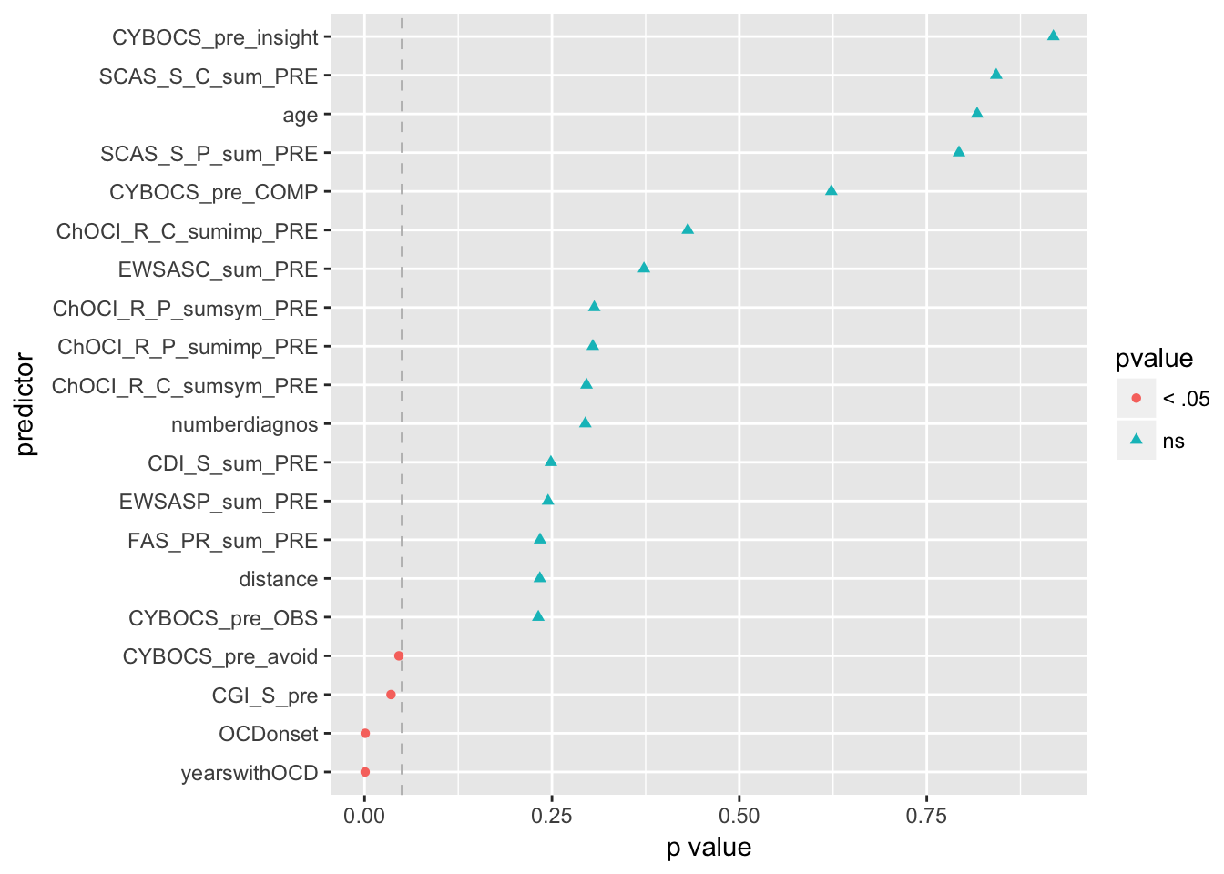

Online supplement X: p-values for unpaired t-tests (two-sided) for each predictor between the two outcome groups

*Linear model.* The four predictors identified above were submitted to a multiple logistic regression. This model is the machine learning pendant to classical regression analysis. The differences being that the model is tested on “fresh” data, ie., the test sample, and that we used a stepwise approach to select predictors. The accuracy in the test model was low (Cohen’s Kappa: 0.17). Next, a linear model with stepwise feature selection was run. The predictive accuracy in the test model was lower than chance (Cohen’s Kappa < -.37.

*Best subset predictor selection.* Here, we fit a linear model again, but selected the best predictors by computing all possible subsets. More precisely, in this model, a predetermined maximum number of predictors was selected (nmax) according to an optimality criterion that is computed from the set of all possible models. The model with the best fit (based on C-p) included nmax=10 predictors. Accuracy in the test sample was high (Cohen’s Kapa: 0.68).

*L1 Elastic Net (Lasso).* Next we computed an Elastic Net to see whether a flexible model would be able detect patterns more clearly. Accuracy in the test sample was relatively high (Cohen’s Kappa: 0.75). As possibly the test sample (n = 12) was too small to allow for reliable accuracy in prediction, we rerun the model with 40% test sample (n = 24). However, the model yielded less accurate results compared to the previous model (Cohen’s Kappa: 0.58).

*Further models.* Fitting Random Forests and for Support Vector Machines, in different variations, to the data yielded similar results (ie., Cohen’s Kappa between 0.71 and 0.80); see the supplementary materials for details.

*Summary*. In sum, the linear machine learning model achieved similar or slightly higher accuracy compared to the more flexible machine learning models. To aggregate the results in an overview, we counted how often a given predictor was deemed as “important” by each classification model. The predictors that were identified as important most frequently were “years with OCD”, “OCD onset”, and education of parents (university)” (3 times each; see Fig. EEE).

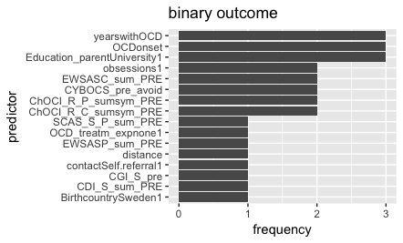

*Figure EEE.* Frequency with which predictors were chosen as important by the models (predicting treatment response at 3-month follow-up).

### Predicting symptom severity (numeric outcome)

*Elastic Net (Lasso)*. First, we ran an Elastic Net where the train sample consisted of 80% of the partipants. R2 amounted to 0.18 in the test sample. In order to check whether the train sample may have been too small we re-fitted the Lasso with same parameters but on a 60-40 sample split; R squared in the test sample was of similar strength (0.20) as in the 80-20 model.

*Random Forest*. A Random Forests model (1000 trees each, with 15 different variants of maximum number of included predictors) yielded a somewhat superior fit (R square in test sample: 0.23)..

*Support Vector Machines (SVM) with radial kernel.* This model was not able to detect much pattern. In the test sample only approx. 5% of the variance was accounted for by this model.

*Stochastic Gradient Boosting.*  This Boosting algorithm was fitted with a tuning length of 10 (interaction depth values 1 to 10). R squared in the test sample was comparatively low, 0.15.

*Summary*. In sum, Random Forest model and the Lasso model resulted as the best fitted models. Regarding predictors, we extracted the 10 variables deemed most important by each model, and counted the frequency across models; see Figure FFF.

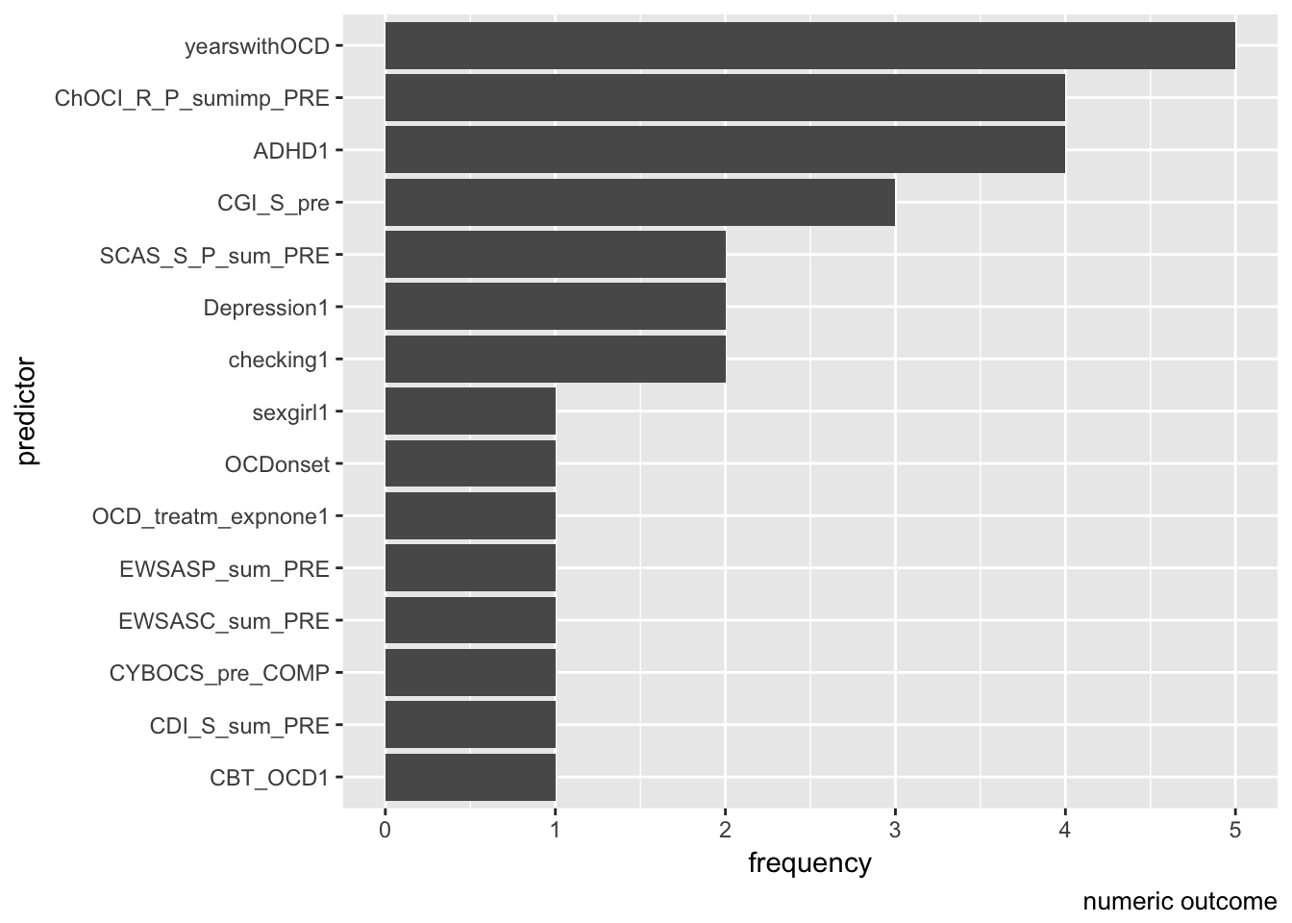

*Figure FFF.*  Frequency by which predictors were chosen as important by the models (numeric outcome).

Finally, we integrated the predictors deemed relevant by both binary and numeric machine learning models to provide a summary (see Figure ZZZ).

As can be seen (Figure ZZZ), the number of years someone lived with OCD was by far the predictors which most models identified as relevant. The longer a patient had to live with OCD, the less likely he or she will be to respond to treatment.

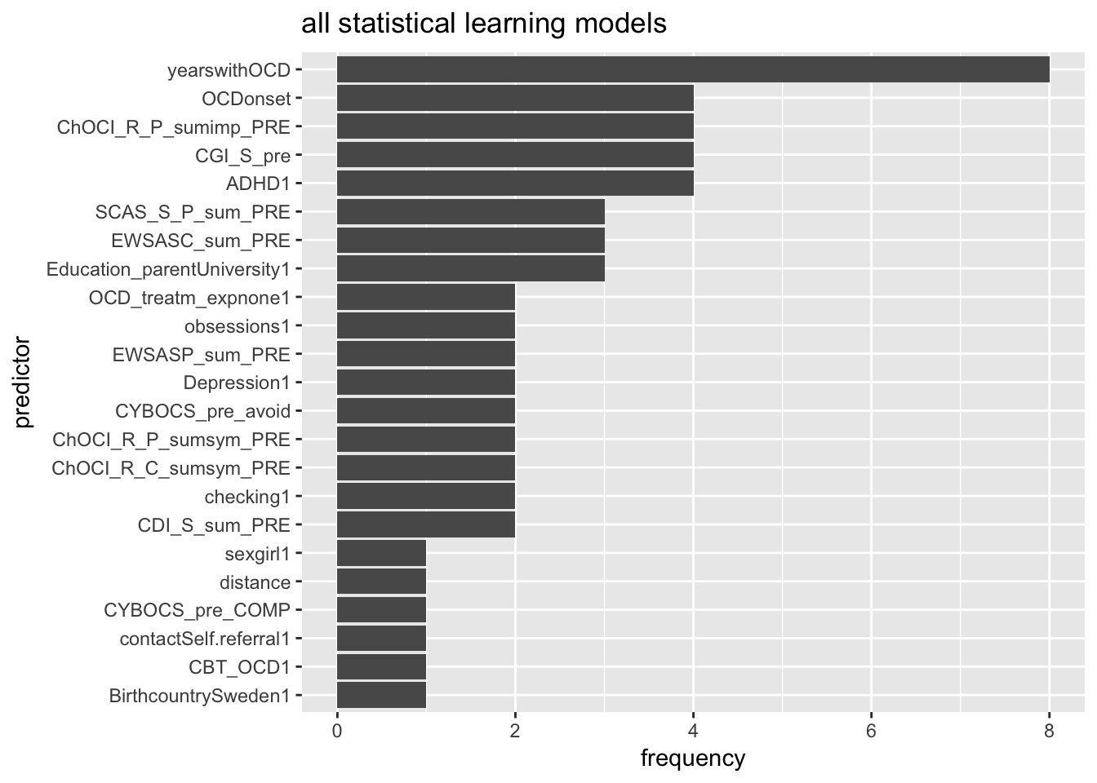

Figure ZZZ: Frequency with which a predictor was selected as relevant by one machine learning model (both for binary and numeric outcome).

# Discussion

The aim of this study was to identify relevant clinical baseline predictors for the outcome of ICBT in adolescents with OCD. We also aimed to describe the importance of different statistical approaches when predicting clinical outcome. Specifically, we compared a traditional regression analytic approach with a novel machine learning approach. Results showed that the traditional regression approach blabla. The machine learning model on the ot.

NÄSTA STYCKE JÄMFÖR DU DINA RESULTAT MED TIDIGARE LITTERATUR OCH DU MENAR ATT DET FINNS EN MASSA KANDIDATER MEN VÅR NYA GRYMMA METOD GÖR ATT DESSA KANDIDATER ÄR SUPERVIKTIGA.

NÄSTA STYCKE DISKUTERAR DU VAD SOM ÄR VIKTIGT MED DESSA PREDIKTORER OCH VAD MAN SKA GÖRA ÅT DEM FÖRUTOM ATT KONSTATERA ATT DET KOMMER GÅ SÄMRE FÖR DESSA OCH NU VET VI DET PÅ FÖRHAND.

## Implications

Our results imply several important considerations for the field of pediatric OCD treatment outcome prediction. Firstly, the chosen multi-method approach demonstrated that the majority of predictors only reached significance once or twice when tested in multiple models, suggesting that results are highly dependent on statistical method. This is an important finding as the vast majority of researchers rely on one statistical method only, i.e. classical regression. On the other hand, a subset of predictors remained significant predictors over several trials of analyses with different statistical approaches, suggesting that those predictors were relatively reliable and may be clinically meaningful predictors of the outcome. This finding sheds new light on the inconsistencies in the previous literature, where few robust predictors could be identified or where the variability of statistical models were not taken into account. In contrast to previous research, the central predictors identifies here are (more) robust towards the choice of the statistical method.

As a broad range of different statistical methods were used, and results also varied, one could hypothesize that some degree of differences in results has been caused by differences in the chosen statistical models. Thus, to reduce inconsistencies due to statistical methods, a sensible recommendation for future studies could be to apply several statistical models in order to test robustness of predictors across methods.

## Limitations

Sample size, for regression analyses with many predictors, and when using training and test-sampling method.

Generalizability.

Context of ICBT, but method findings possibly are relevant for face-to-face CBT as well.

## Conclusion

# References

American Psychiatric Association. (2013). *Diagnostic and statistical manual of mental disorders, DSM 5* (5th ed). Arlington, VA: American Psychiatric Publishing.

Askland, K. D., Garnaat, S., Sibrava, N. J., Boisseau, C. L., Strong, D., Mancebo, M., … Eisen, J. (2015). Prediction of remission in obsessive compulsive disorder using a novel machine learning strategy. *International Journal of Methods in Psychiatric Research*, *24*(2), 156–169. http://doi.org/10.1002/mpr.1463

Berk, M., Ng, F., Dodd, S., Callaly, T., Campbell, S., Bernardo, M., & Trauer, T. (2008). The validity of the CGI severity and improvement scales as measures of clinical effectiveness suitable for routine clinical use. *Journal of Evaluation in Clinical Practice*, *14*(6), 979–983. Retrieved from http://www.ncbi.nlm.nih.gov/pubmed/18462279

Breiman, L. (2001). Statistical Modeling: The Two Cultures. *Statistical Science*, *16*(3), 199–231. http://doi.org/10.2307/2676681

Buuren, S. van, & Groothuis-Oudshoorn, K. (2011). mice : Multivariate Imputation by Chained Equations in R. *Journal of Statistical Software*, *45*(3), 1–67. http://doi.org/10.18637/jss.v045.i03

Flessner, C. A., Sapyta, J., Garcia, A., Freeman, J. B., Franklin, M. E., Foa, E., & March, J. (2009). Examining the Psychometric Properties of the Family Accommodation Scale-Parent-Report (FAS-PR). *Journal of Psychopathology and Behavioral Assessment*, *31*(1), 38–46. Retrieved from http://www.pubmedcentral.nih.gov/articlerender.fcgi?artid=3131184&tool=pmcentrez&rendertype=abstract

Garcia, A. M., Sapyta, J. J., Moore, P. S., Freeman, J. B., Franklin, M. E., March, J. S., & Foa, E. B. (2010). Predictors and Moderators of Treatment Outcome in the Pediatric Obsessive Compulsive Treatment Study (POTS I). *Journal of the American Academy of Child & Adolescent Psychiatry*, *49*(10), 1024–1033. http://doi.org/10.1016/j.jaac.2010.06.013

Ginsburg, G. S., Kingery, J. N., Drake, K. L., & Grados, M. A. (2008). Predictors of treatment response in pediatric obsessive-compulsive disorder. *Journal of the American Academy of Child and Adolescent Psychiatry*, *47*(8), 868–78. http://doi.org/10.1097/CHI.0b013e3181799ebd

Hastie, T., Tibshirani, R., & Friedman, J. (2009). *The Elements of Statistical Learning: Data Mining, Inference, and Prediction*. *Springer Series in Statistics* (Vol. 2). http://doi.org/10.1007/b94608

James, G., Witten, D., Hastie, T., & Tibishirani, R. (2013). *An Introduction to Statistical Learning*. *Springer Texts in Statistics*. http://doi.org/10.1007/978-1-4614-7138-7

Kovacs, M. (1985). The Children’s Depression, Inventory (CDI). *Psychopharmacology Bulletin*, *21*(4), 995–8. Retrieved from http://www.ncbi.nlm.nih.gov/pubmed/4089116

Lenhard, F., Andersson, E., Mataix-Cols, D., Rück, C., Vigerland, S., Högström, J., … Serlachius, E. (2016). Therapist-Guided, Internet-Delivered Cognitive-Behavioral Therapy for Adolescents With Obsessive-Compulsive Disorder: A Randomized Controlled Trial. *Journal of the American Academy of Child & Adolescent Psychiatry*. http://doi.org/10.1016/j.jaac.2016.09.515

Lenhard, F., Vigerland, S., Andersson, E., Rück, C., Mataix-Cols, D., Thulin, U., … Serlachius, E. (2014a). Internet-delivered cognitive behavior therapy for adolescents with obsessive-compulsive disorder: An open trial. *PLoS ONE*, *9*(6), e100773. http://doi.org/10.1371/journal.pone.0100773

Lenhard, F., Vigerland, S., Andersson, E., Rück, C., Mataix-Cols, D., Thulin, U., … Serlachius, E. (2014b). Internet-delivered cognitive behavior therapy for adolescents with obsessive-compulsive disorder: an open trial. *PloS One*, *9*(6), e100773. http://doi.org/10.1371/journal.pone.0100773

Lenhard, F., Vigerland, S., Engberg, H., Hallberg, A., Thermaenius, H., & Serlachius, E. (2016). “On My Own, but Not Alone” - Adolescents’ Experiences of Internet-Delivered Cognitive Behavior Therapy for Obsessive-Compulsive Disorder. *Plos One*, *11*(10), e0164311. http://doi.org/10.1371/journal.pone.0164311

Mancebo, M. C., Boisseau, C. L., Garnaat, S. L., Eisen, J. L., Greenberg, B. D., Sibrava, N. J., … Rasmussen, S. A. (2014). Long-term course of pediatric obsessive-compulsive disorder: 3 years of prospective follow-up. *Comprehensive Psychiatry*, *55*(7), 1498–504. http://doi.org/10.1016/j.comppsych.2014.04.010

Mataix-Cols. (2005). Reliability and validity of the Work and Social Adjustment Scale in phobic disorders. *Comprehensive Psychiatry*, *46*.

Mataix-Cols, D., De La Cruz, L. F., Nordsletten, A. E., Lenhard, F., Isomura, K., & Simpson, H. B. (2016). Towards an international expert consensus for defining treatment response, remission, recovery and relapse in obsessive-compulsive disorder. *World Psychiatry*, *15*(1). http://doi.org/10.1002/wps.20299

Mataix-Cols, D., & Marks, I. M. (2006). Self-help with minimal therapist contact for obsessive–compulsive disorder: a review. *European Psychiatry*, *21*(2), 75–80. Retrieved from http://www.sciencedirect.com/science/article/pii/S0924933805001550

Monuteaux, M. C., & Stamoulis, C. (2016). Machine Learning: A Primer for Child Psychiatrists. *Journal of the American Academy of Child & Adolescent Psychiatry*. http://doi.org/10.1016/j.jaac.2016.07.766

Peris, T. S., Sugar, C. A., Bergman, R. L., Chang, S., Langley, A., & Piacentini, J. (2012). Family factors predict treatment outcome for pediatric obsessive-compulsive disorder. *Journal of Consulting and Clinical Psychology*, *80*(2), 255–63. http://doi.org/10.1037/a0027084

R Core Team. (2015). R: A Language and Environment for Statistical Computing. Vienna, Austria. Retrieved from http://www.r-project.org

Rees, C. S., Anderson, R. A., Kane, R. T., & Finlay-Jones, A. L. (2016). Online Obsessive-Compulsive Disorder Treatment: Preliminary Results of the “OCD? Not Me!” Self-Guided Internet-Based Cognitive Behavioral Therapy Program for Young People. *JMIR Mental Health*, *3*(3), e29. http://doi.org/10.2196/mental.5363

Rudy, B. M., Lewin, A. B., Geffken, G. R., Murphy, T. K., & Storch, E. A. (2014). Predictors of treatment response to intensive cognitive-behavioral therapy for pediatric obsessive-compulsive disorder. *Psychiatry Research*, *220*(1–2), 433–40. http://doi.org/10.1016/j.psychres.2014.08.002

Scahill, L., Riddle, M. A., McSwiggin-Hardin, M., Ort, S. I., King, R. A., Goodman, W. K., … Leckman, J. F. (1997). Children’s Yale-Brown Obsessive Compulsive Scale: reliability and validity. *Journal of the American Academy of Child and Adolescent Psychiatry*, *36*(6), 844–52. http://doi.org/10.1097/00004583-199706000-00023

Shafran, R., Frampton, I., Heyman, I., Reynolds, M., Teachman, B., & Rachman, S. (2003). The preliminary development of a new self-report measure for OCD in young people. *Journal of Adolescence*, *26*(1), 137–42. Retrieved from http://www.ncbi.nlm.nih.gov/pubmed/12550826

Spence, S. H. (1998). A measure of anxiety symptoms among children. *Behaviour Research and Therapy*, *36*(5), 545–66. Retrieved from http://www.ncbi.nlm.nih.gov/pubmed/9648330

Torp, N. C., Dahl, K., Skarphedinsson, G., Compton, S., Thomsen, P. H., Weidle, B., … Ivarsson, T. (2014). Predictors Associated With Improved Cognitive-Behavioral Therapy Outcome in Pediatric Obsessive-Compulsive Disorder. *Journal of the American Academy of Child & Adolescent Psychiatry*, *54*(3), 200–207.e1. http://doi.org/10.1016/j.jaac.2014.12.007